

**FINAL RELEASE DOCUMENT**

**Clinic Booking**

– Hanoi, Mar 2022 –

**Table of Contents**

I. Deliverable Package **3**

II. Installation Guides **3**

III. User Manual **3**

1. Overview 3

2.Workflow 3

2.1. Admin 4

2.2. Doctor 6

2.3. Staff 7

2.4. Marketing 8

2.5. Patient 9

2.6. Guest 11

**I. Deliverable Package**

| **No.** | **File** | **Notes** |
| --- | --- | --- |
| 1 | G3_CBS_DB_final.sql | Database, including both table structures and table data |
| 2 | G3_CBS_SRS_final.docx | Final SRS (Requirement) Document |
| 3 | G3_CBS_SDS_final.docx | Final SDS (Design) Document |
| 4 | G3_CBS_Functions Report.xlsx | Final status for the application functions, which include:  - Function name, feature, roles, function description (changes compared to the original requirements are highlighted)  - In Charge, Planned iteration & Actual iteration  - Final status & note on the update you made  - The links to the SRS & SDS are tracked |
| 5 | G3_CBS_Tasks Report.xlsx | Final tasks tracking list of the whole project |
| 6 | G3_CBS_Pending Issues.xlsx | Pending Issues tracking list the whole Project |
| 7 | G3_CBS_Presentation .pptx | Project presentation slides |

Other related deliverables:

* Tagged source codes [FinalRelease](https://gitlab.com/fu-swp/spring22/se1516-net_swp391/g3/-/tags/FinalRelease)
* Demonstration video: [SWP391-CLinicBooking](https://youtu.be/PYgCORWFZhI)
* Link website : [Doctris - Tìm bác sĩ chính xác - Đặt lịch khám dễ dàng (doctriscare.ml)](https://doctriscare.ml/)

**II. Installation Guides**

* Environment install
* JDK 8: [Here](https://www.shaileshjha.com/step-by-step-how-to-download-and-install-java-se-jdk-8-on-windows-10/)
* Netbeans r8.2 : [Here](https://notesformsc.org/install-netbeans-ide-8-2-windows/) (version r8.2 is old and no longer supports downloading from Netbeans. Please download via the link : [here](https://drive.google.com/file/d/1j_gPO54FC0FQ3hZ81BzN0qFhqrOxOsHj/view?usp=sharing))
* MySQL : [Here](https://www.sqlshack.com/how-to-install-mysql-database-server-8-0-19-on-windows-10/)
* Database
* Create database name : doctris_system
* Import database ClinicBooking_DB_final.sql
* Run Code
* Open code using netbeans 8.2
* Add server : using GlassFist server
* Go to resource/database.properties – Edit url, username, password
* Run

**III. User Manual**

**1. Overview**

*Clinic System is a web booking system for patients, doctors and clinic staff. This system aims for a friendly interface that is easy to use and responds quickly*

**2.Workflow**

**2.11. Admin**

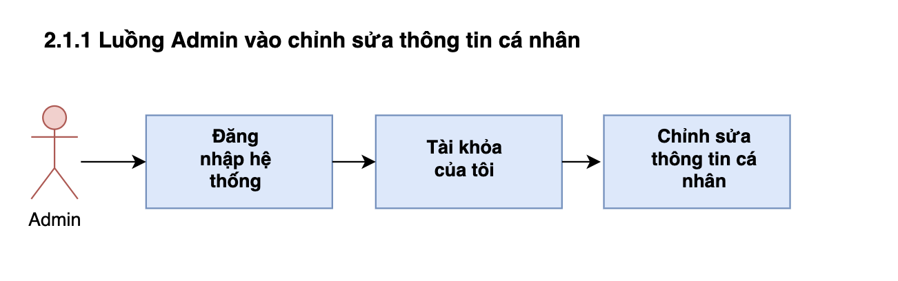

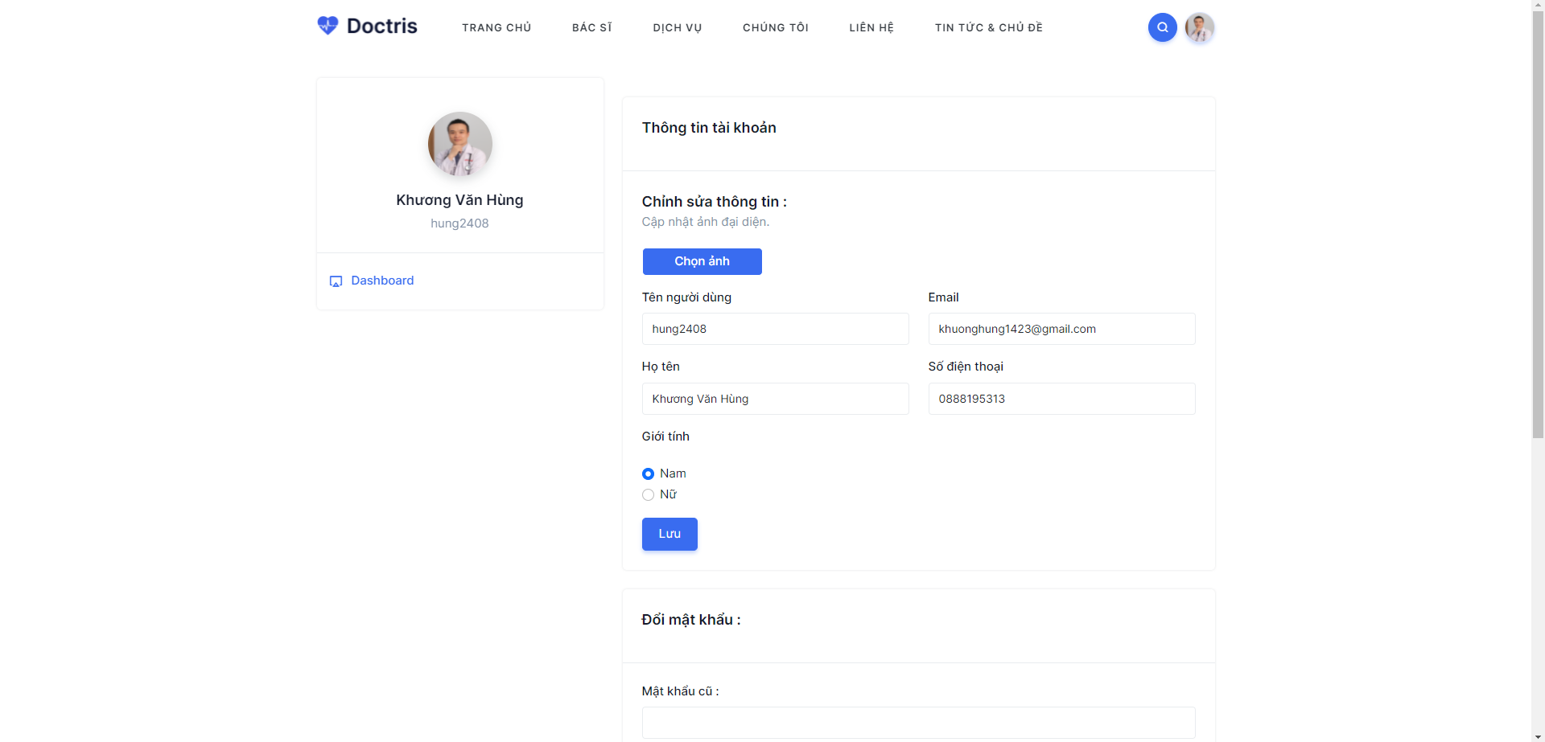

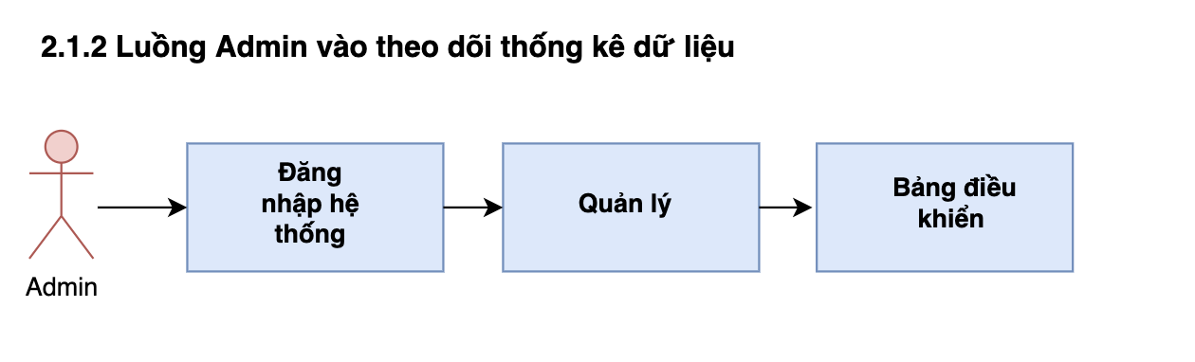

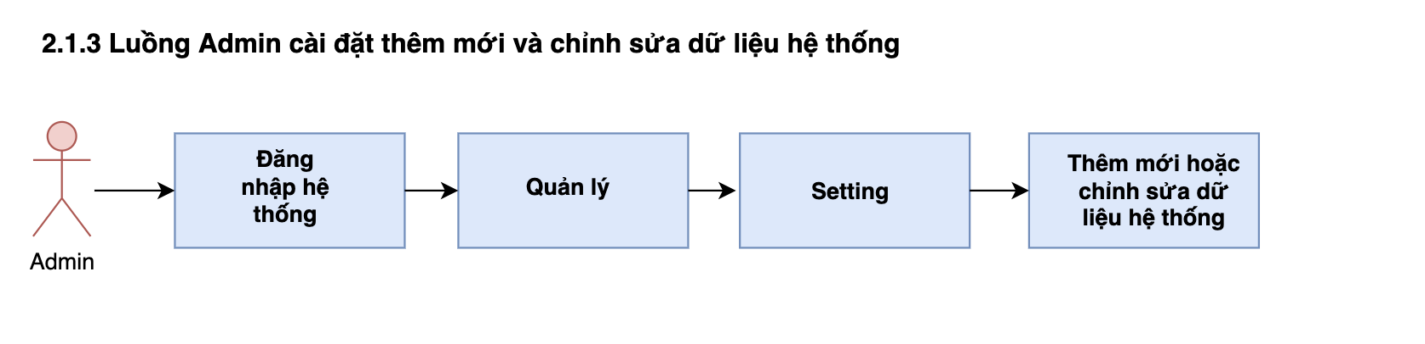

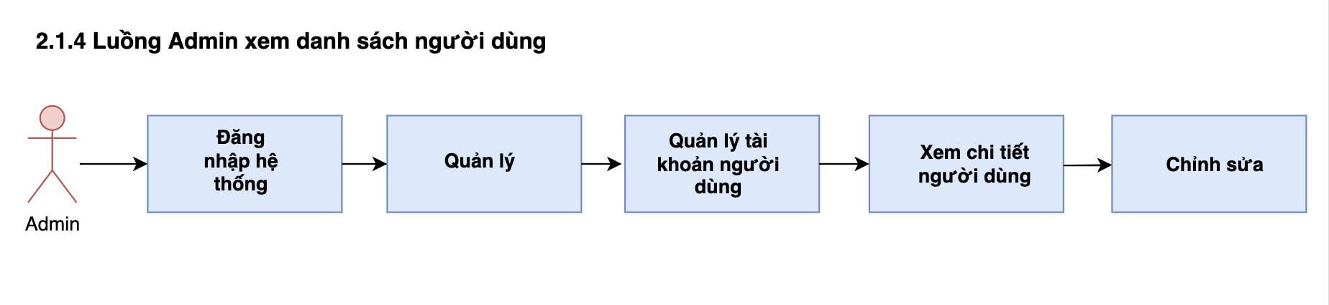

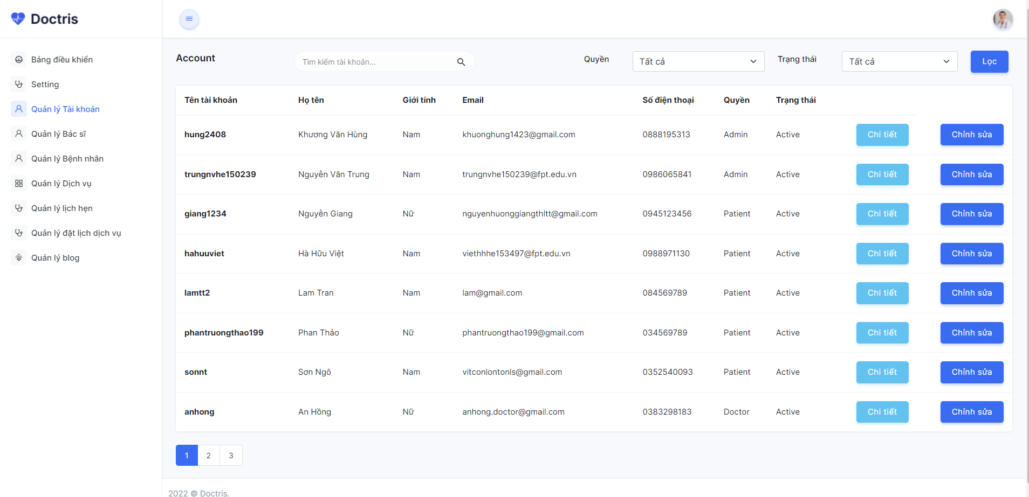

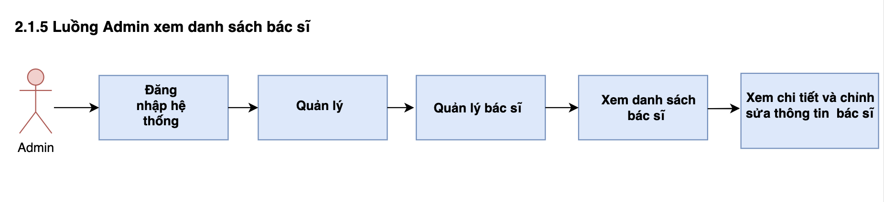

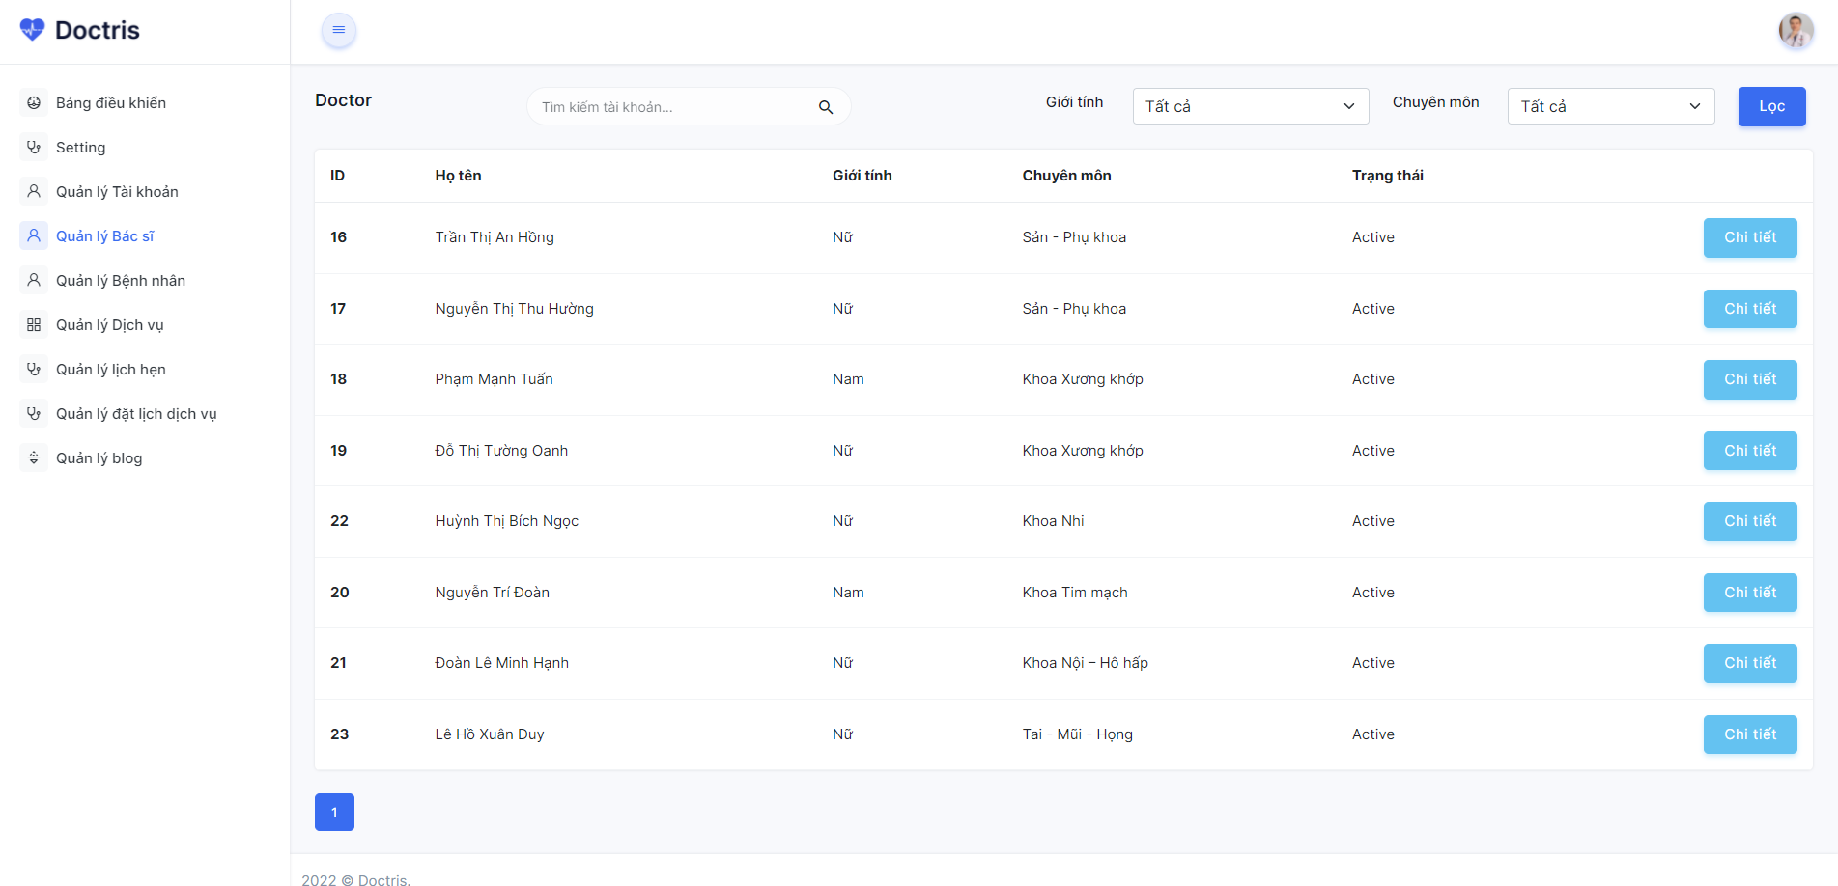

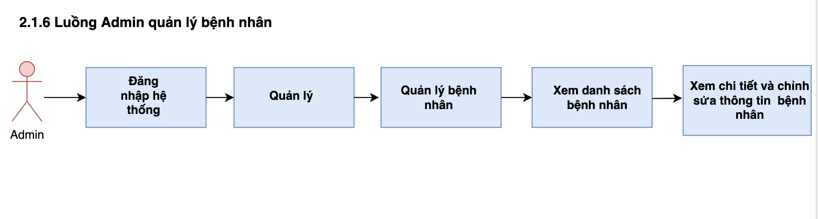

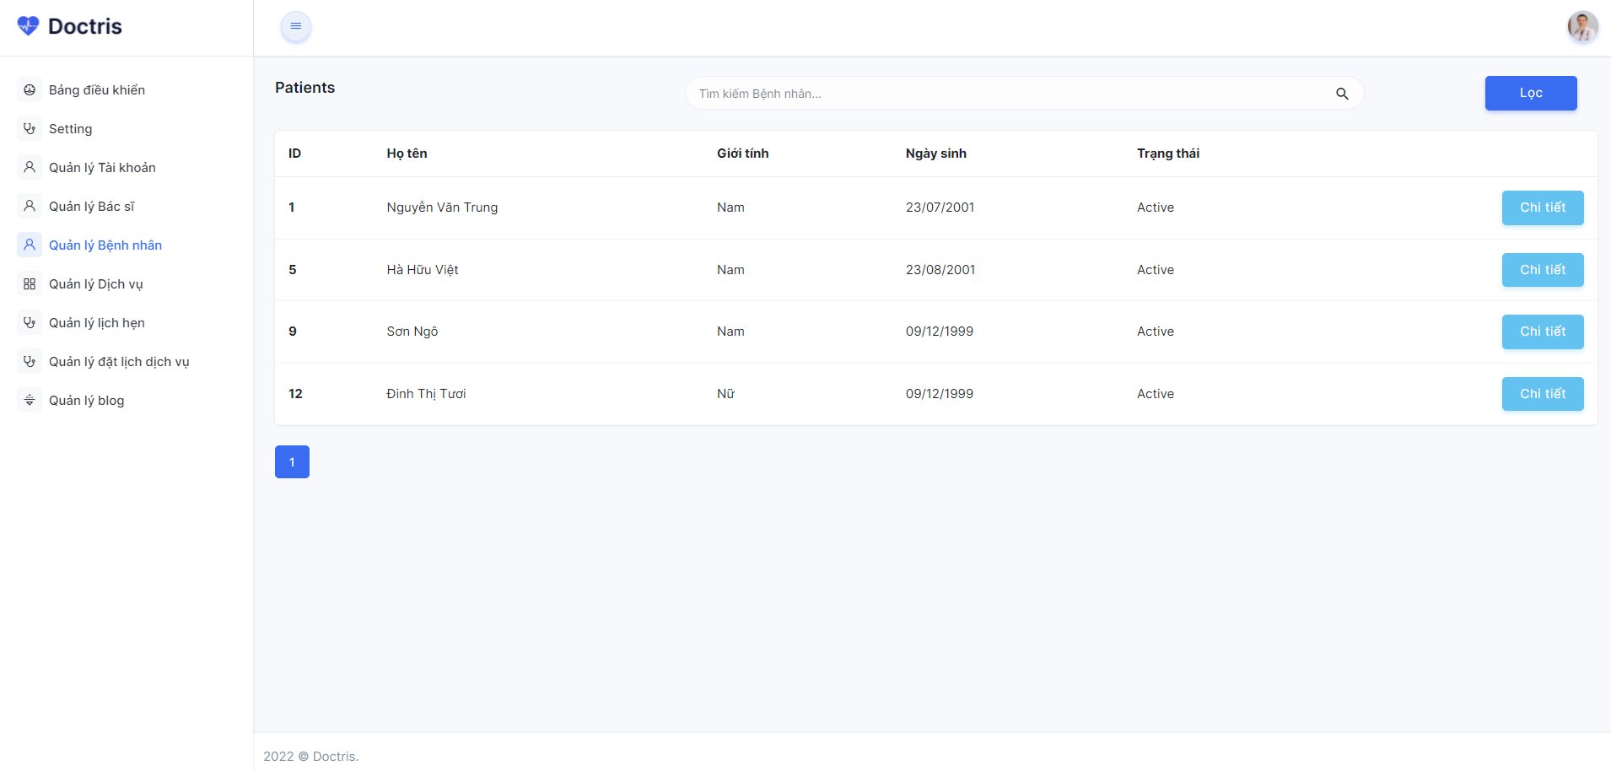

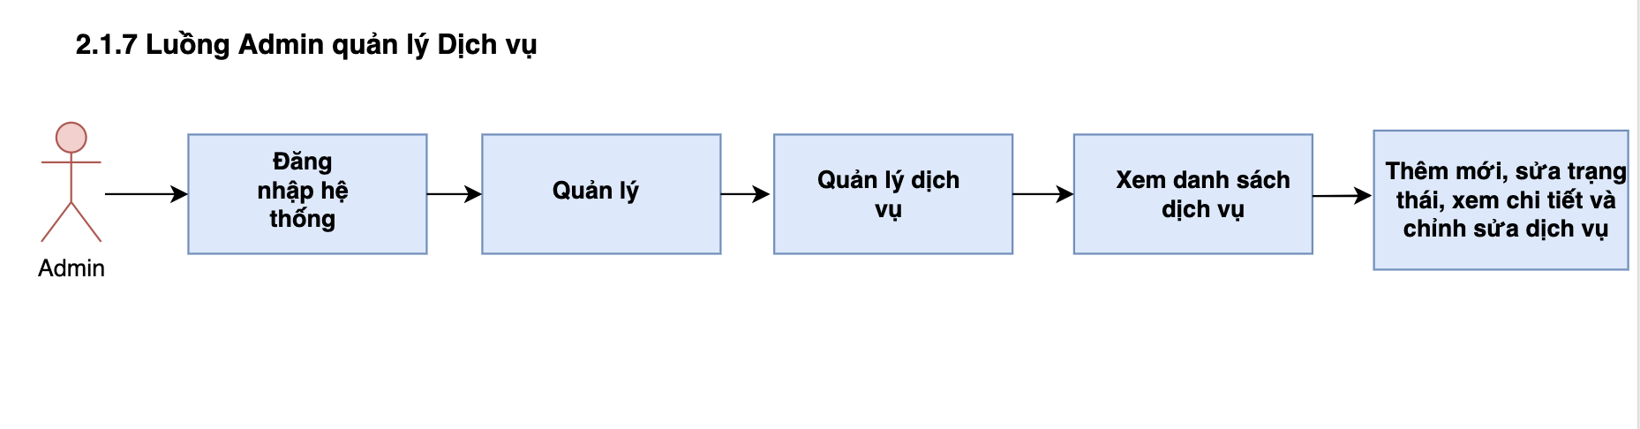

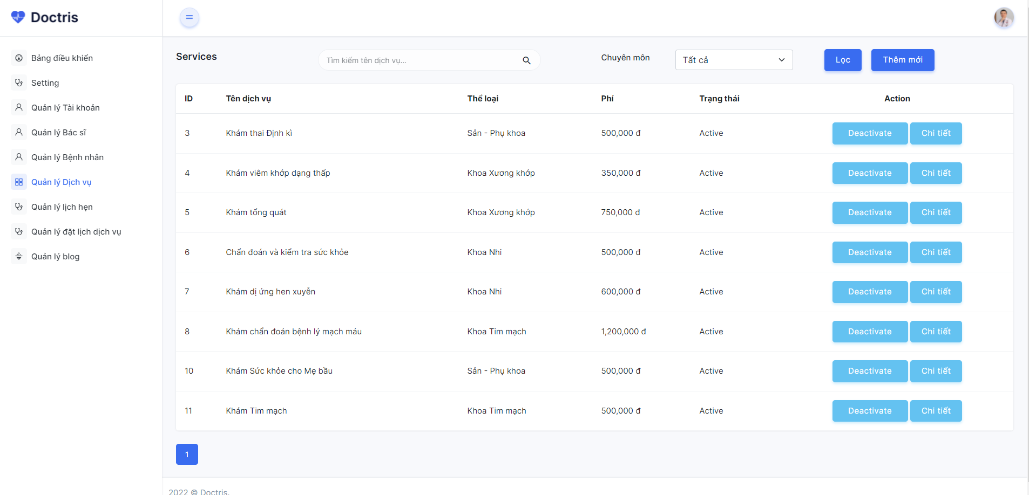

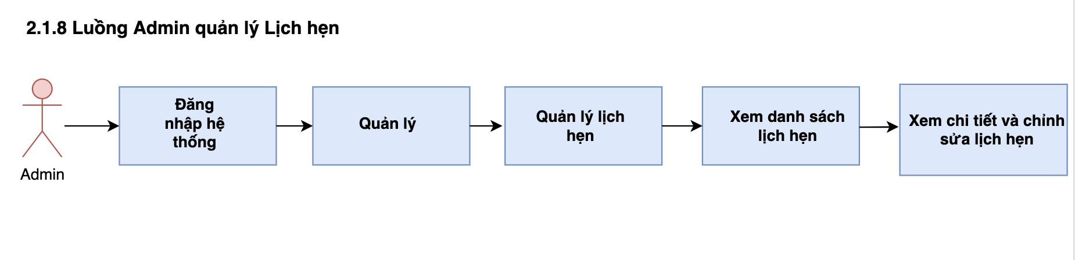

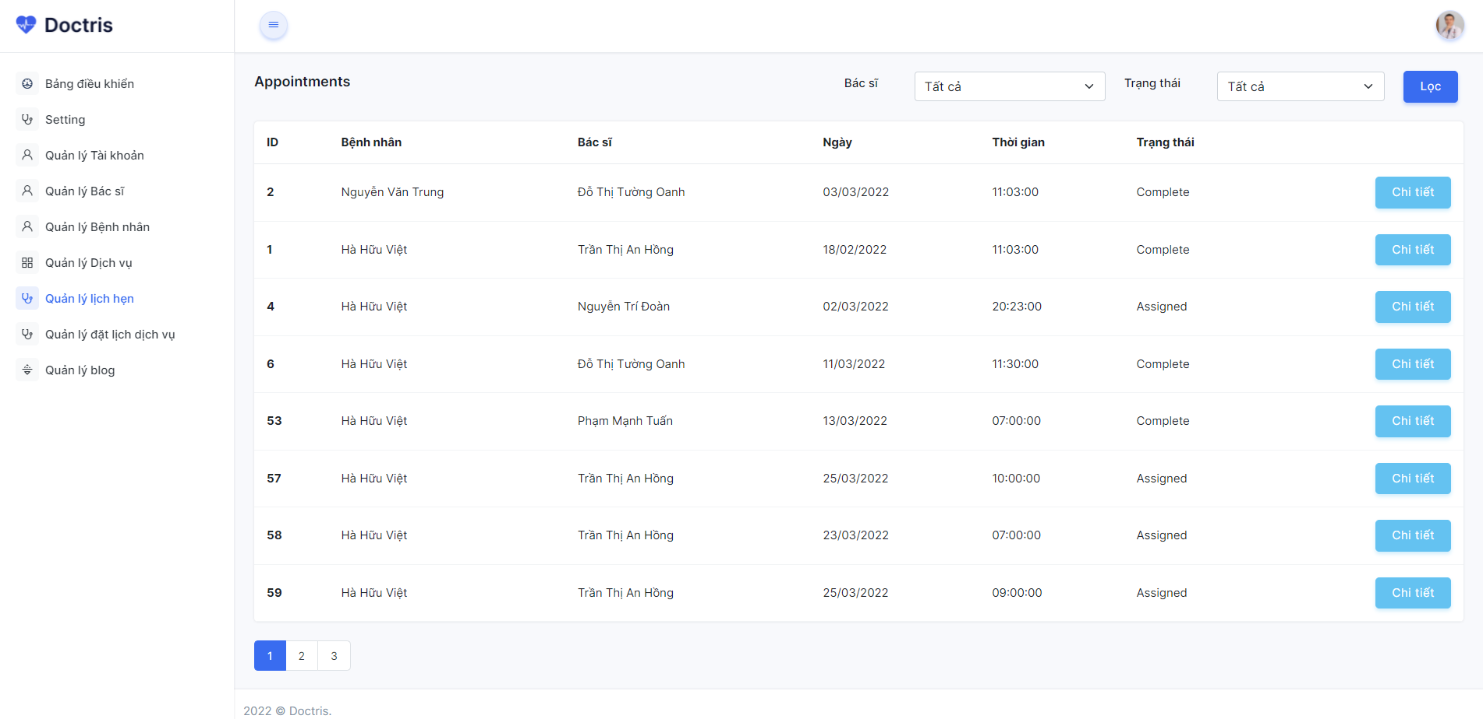

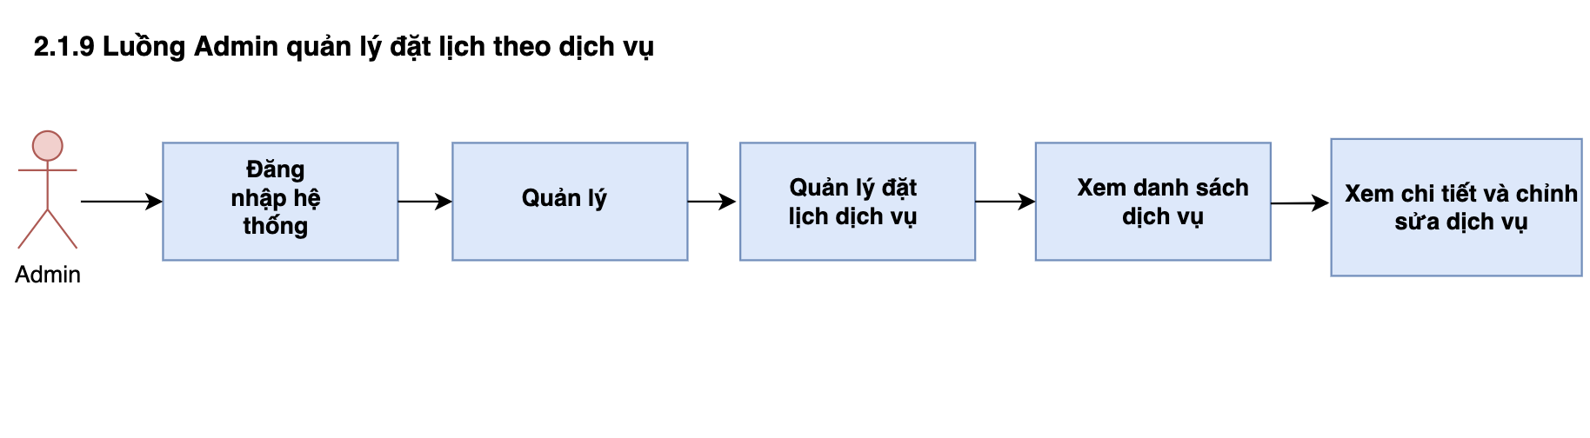

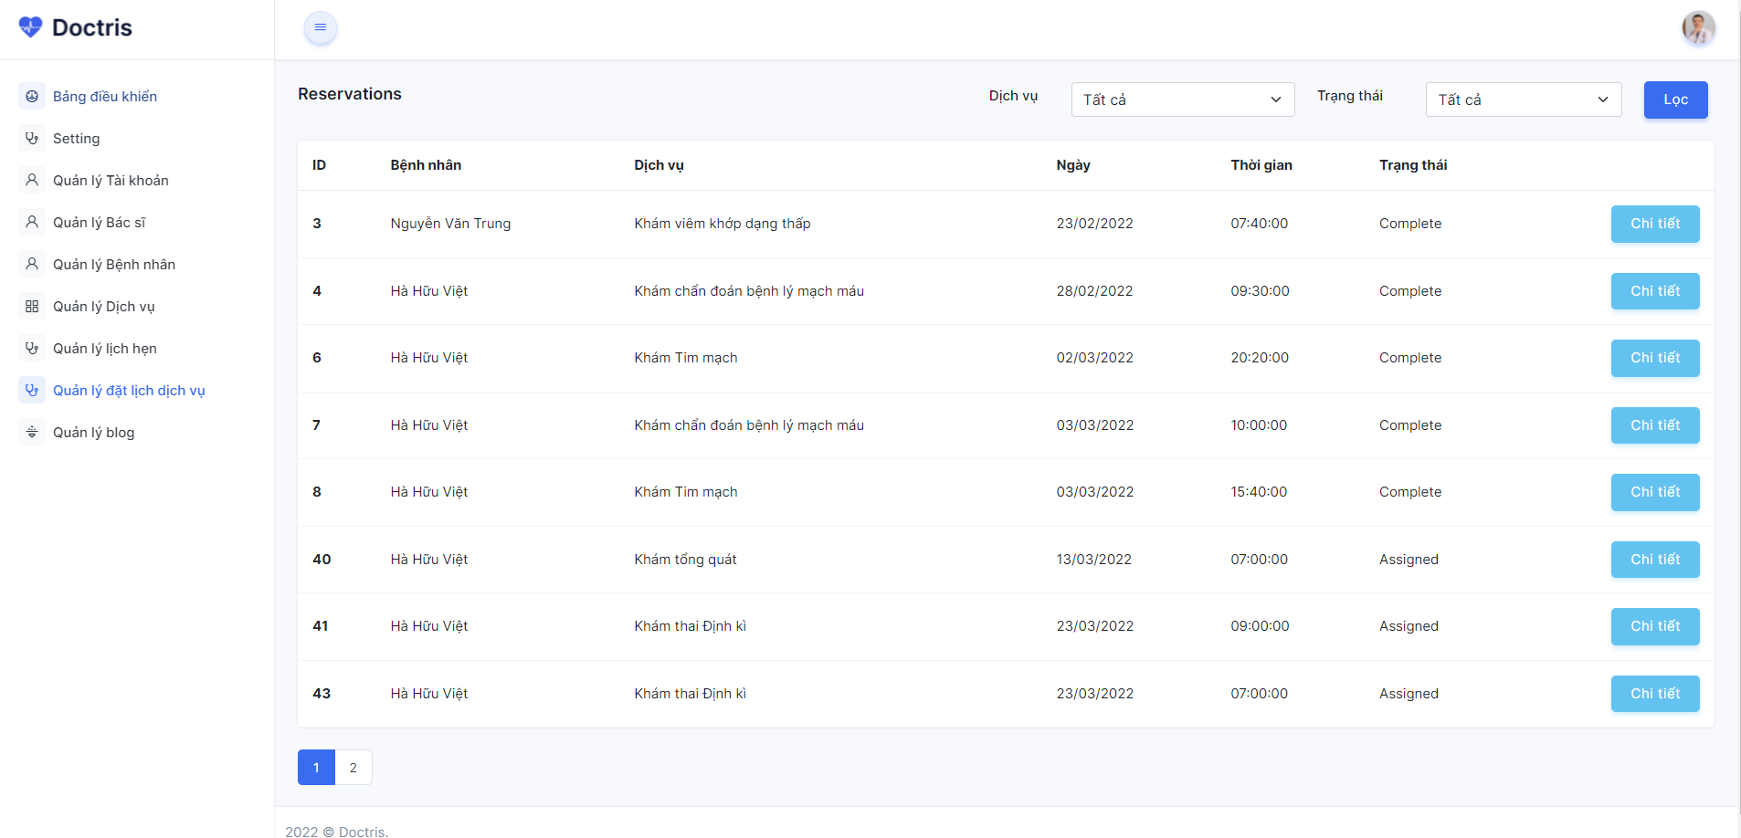

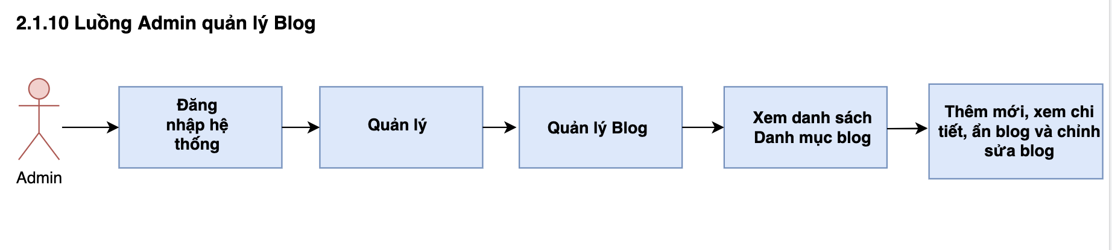

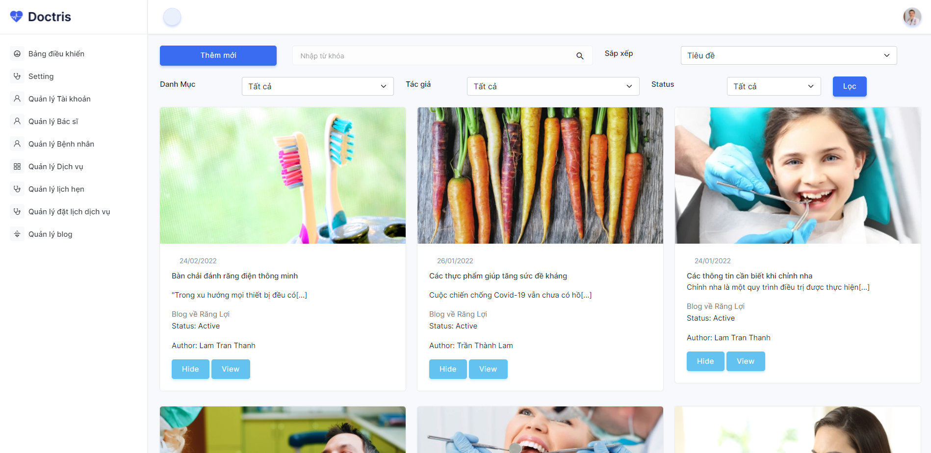

**2.2. Doctor**

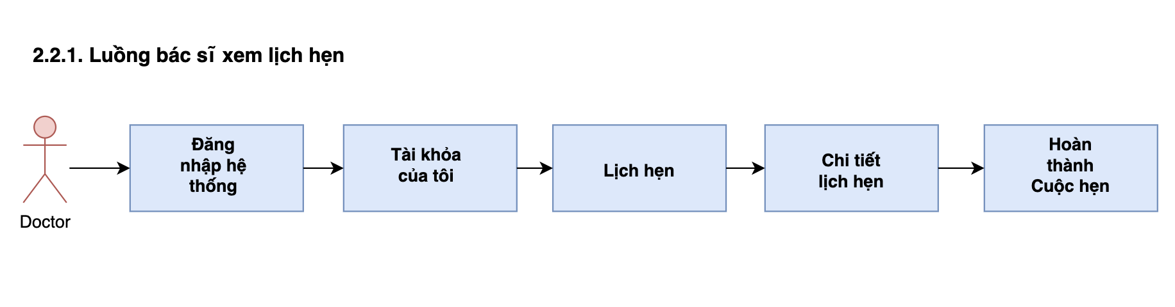

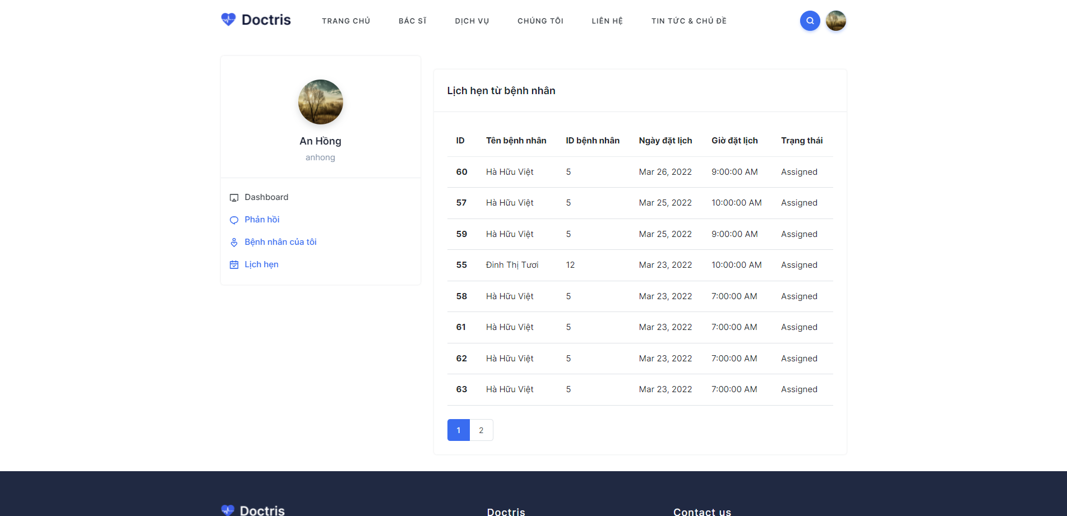

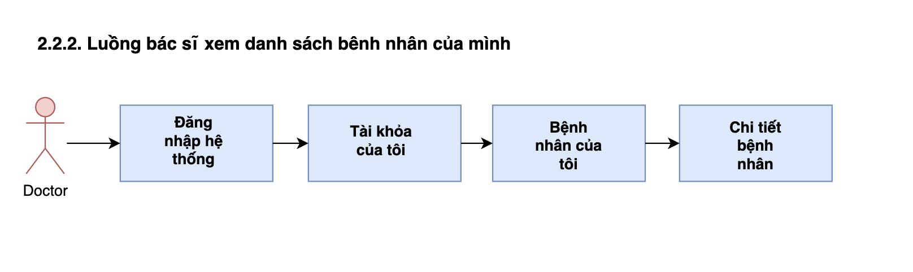

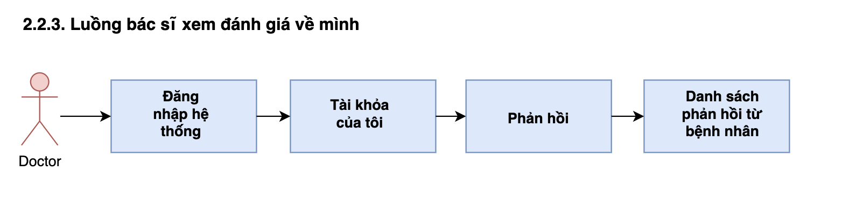

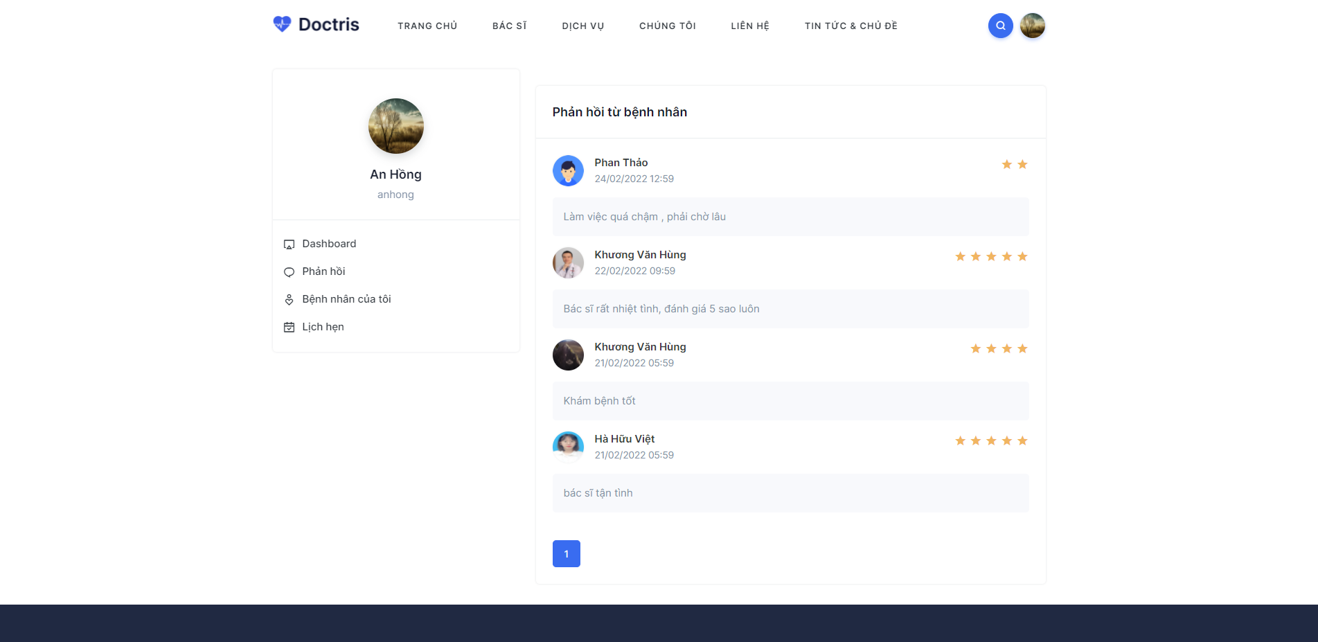

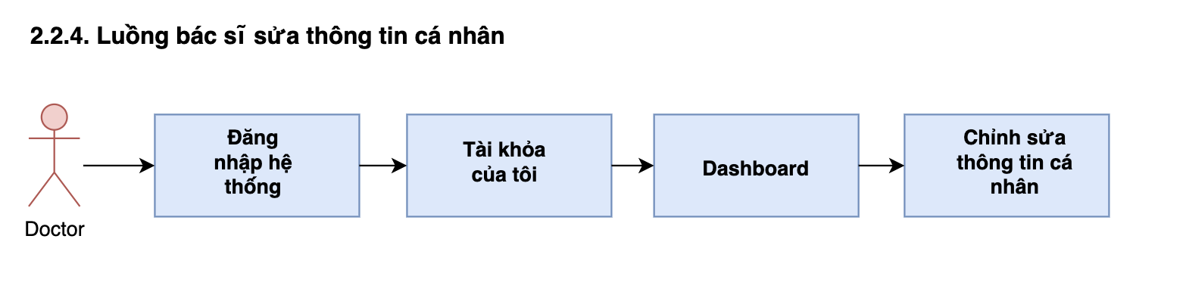

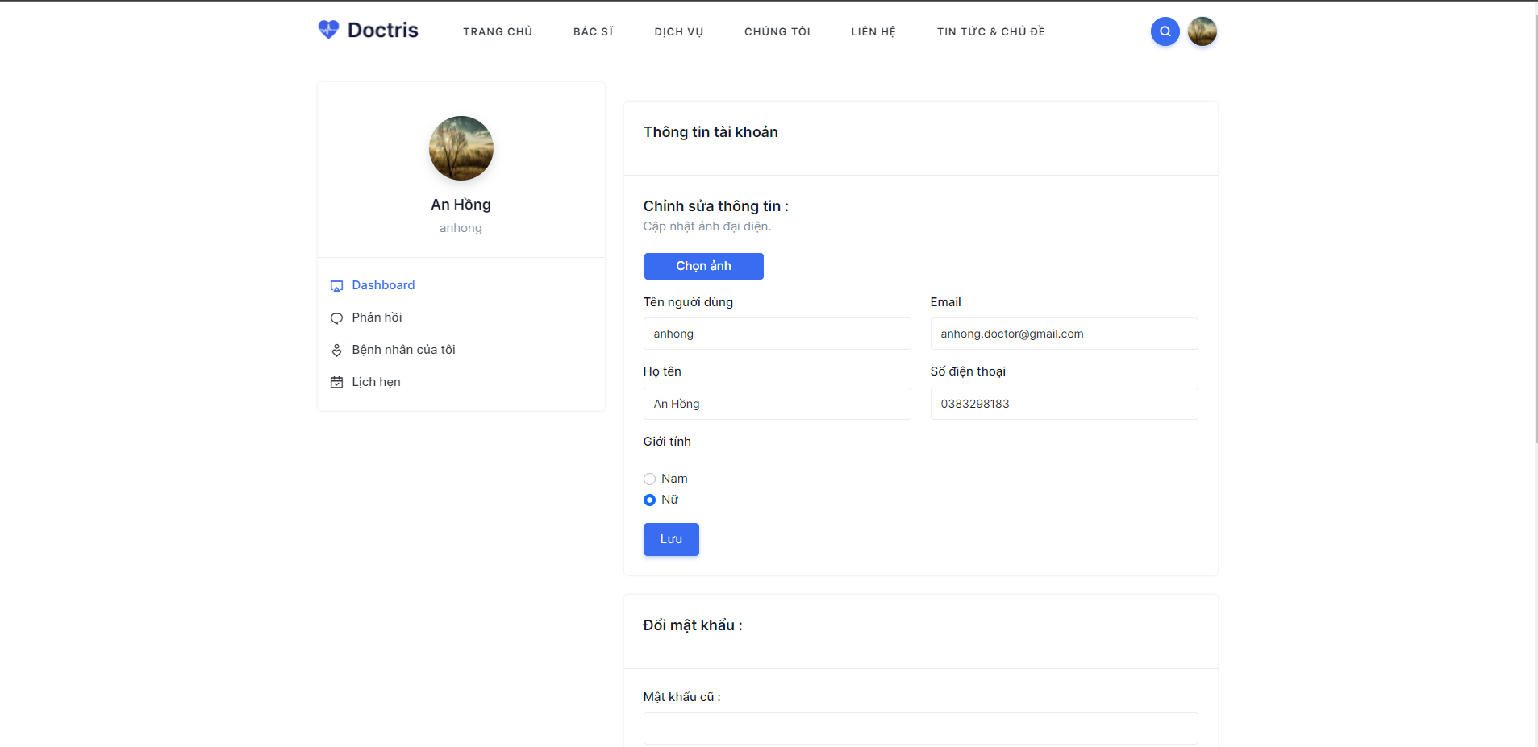

**2.3. Staff**

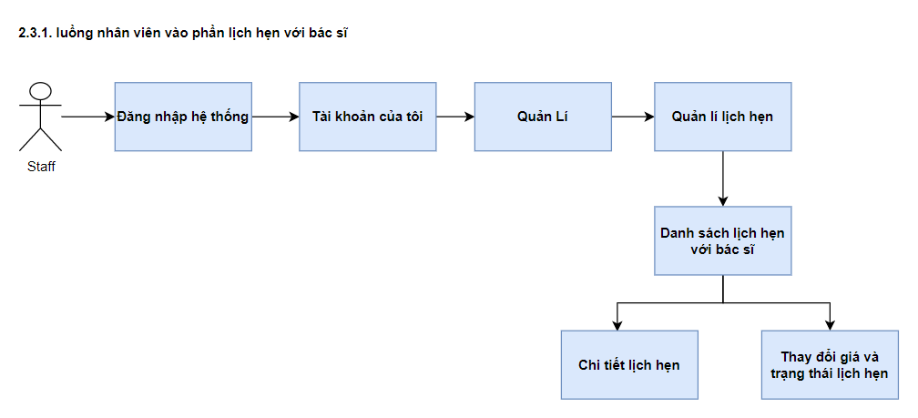

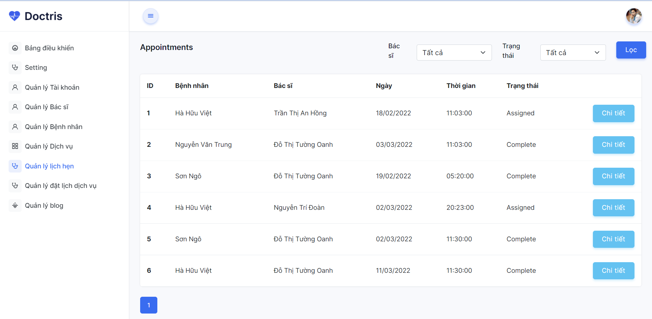

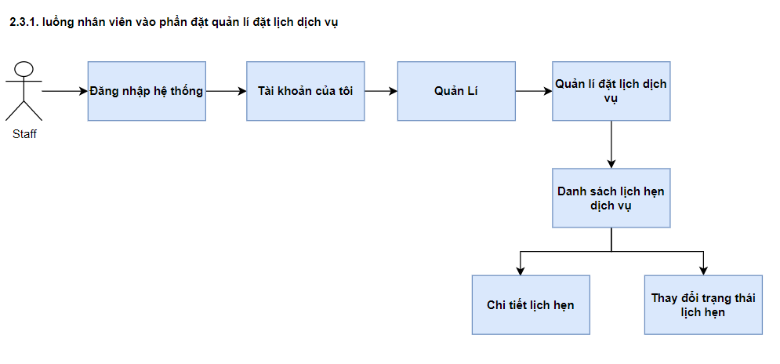

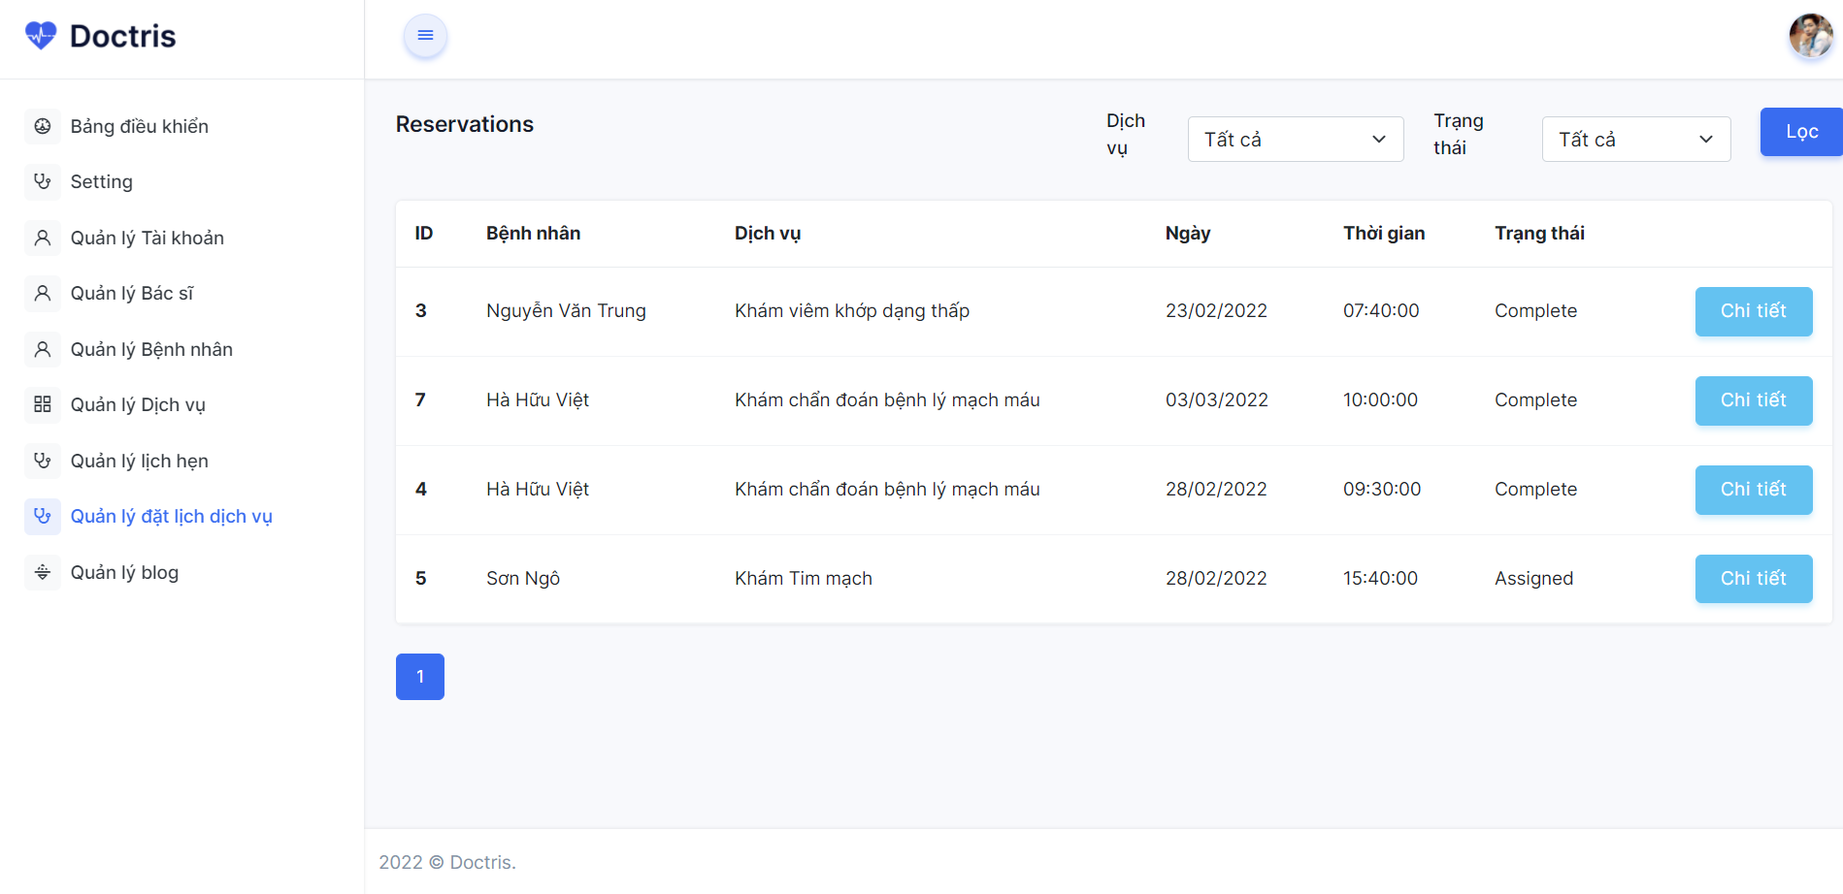

**2.4. Marketing**

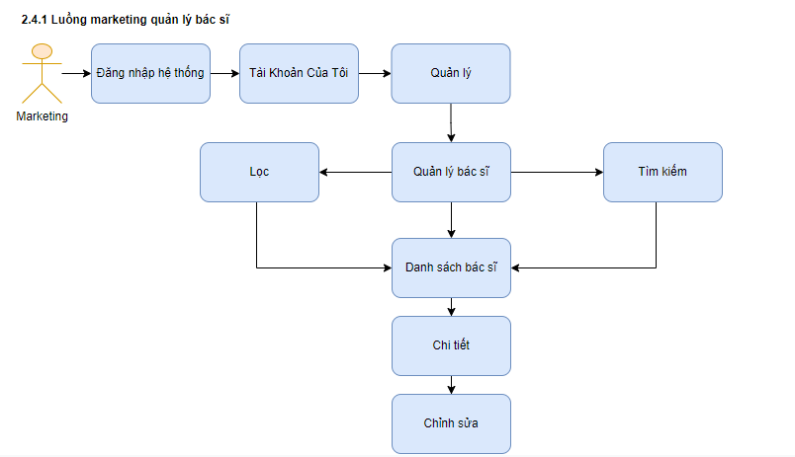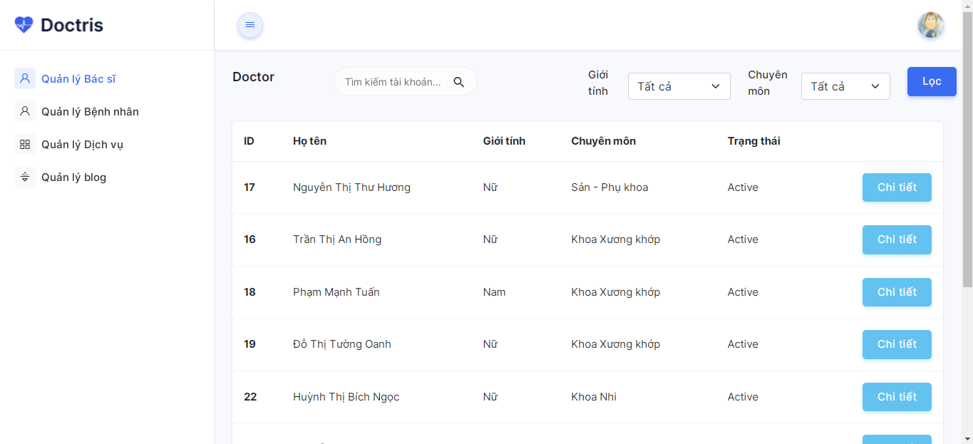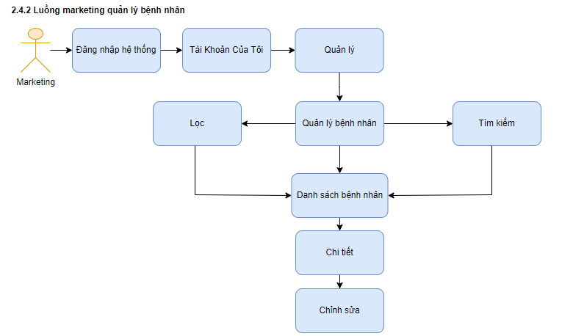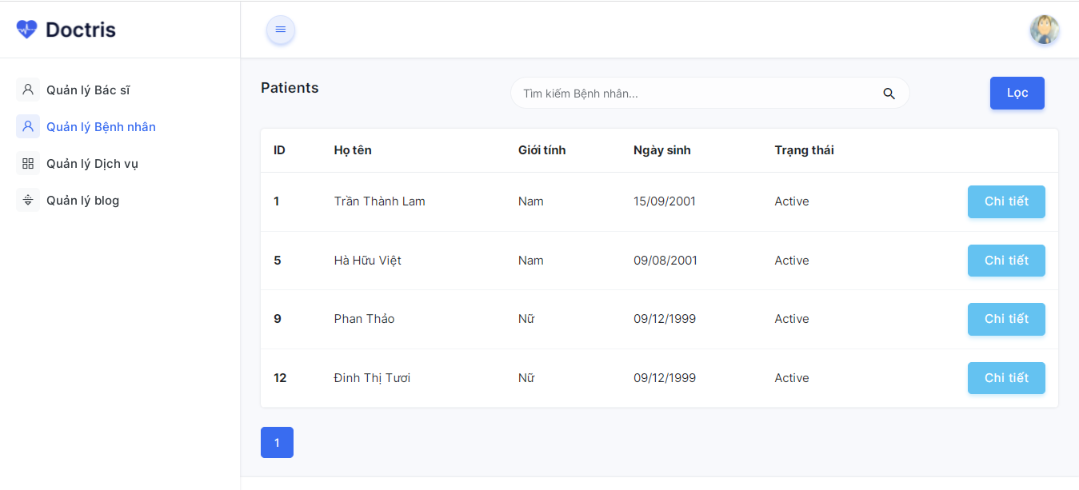

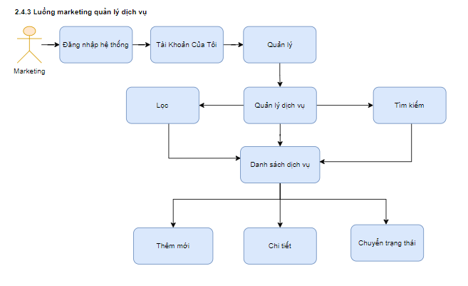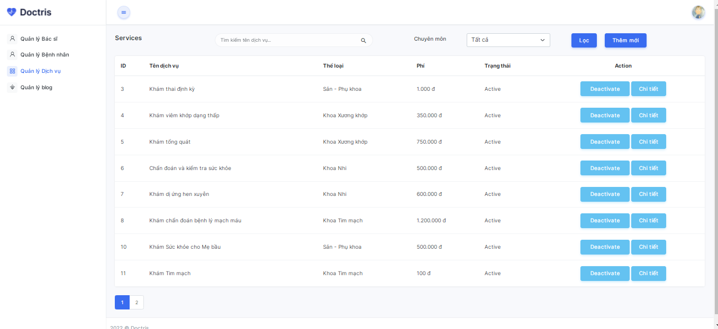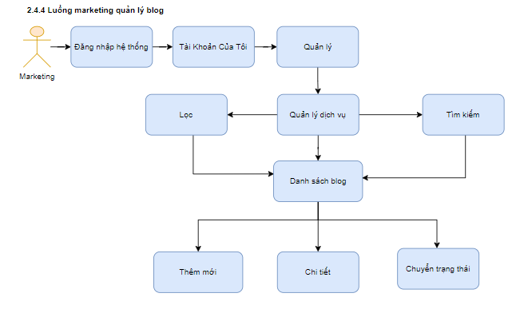

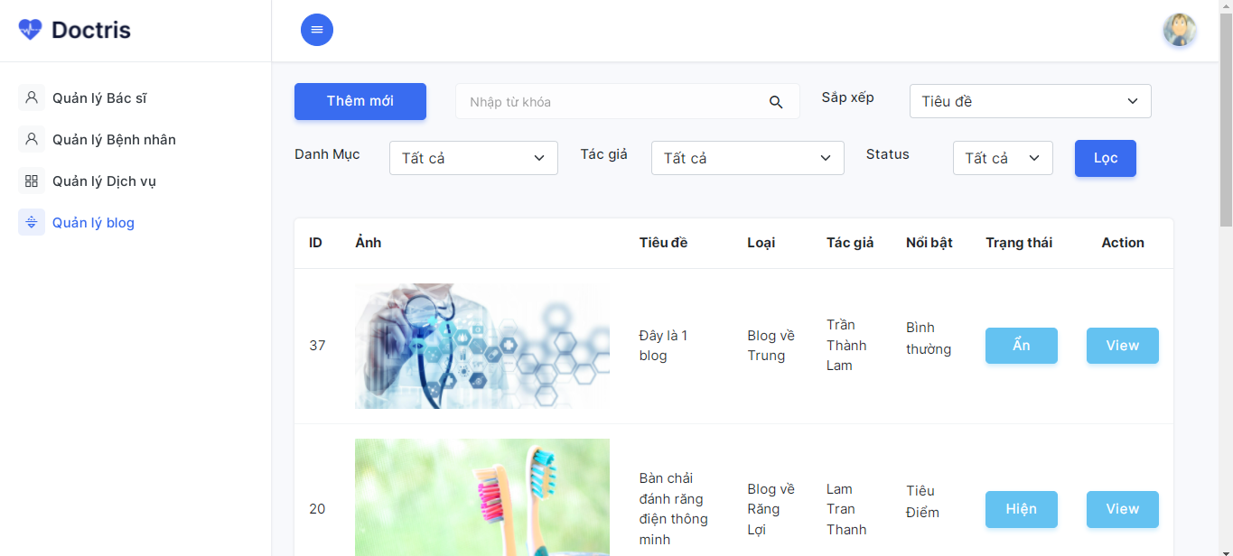

**2.5. Patient**

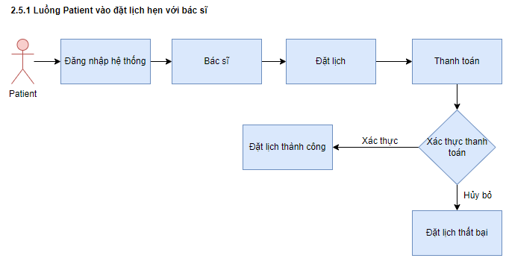

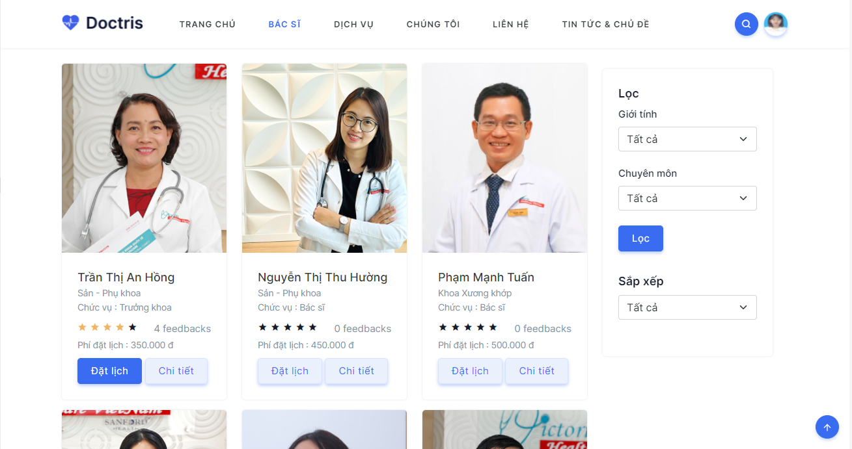

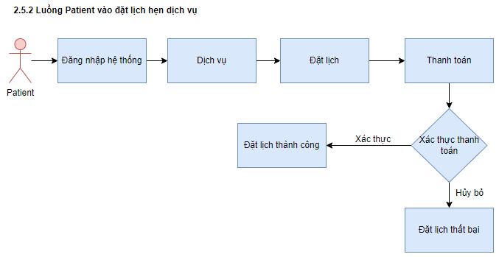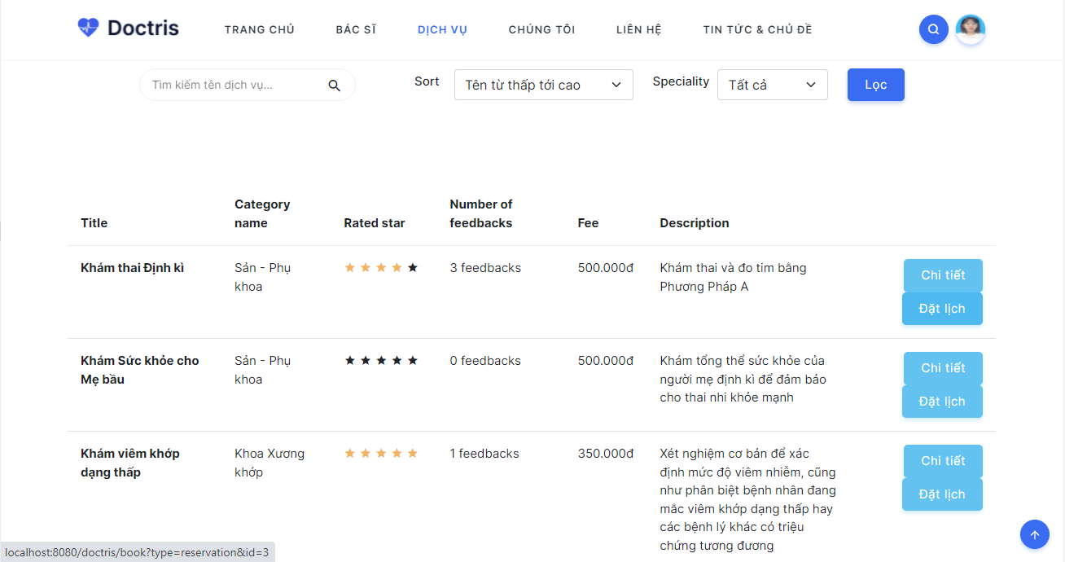

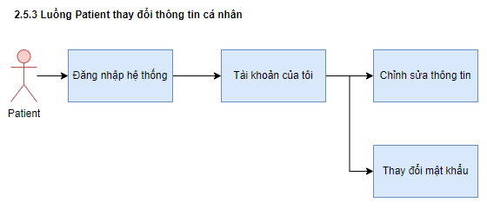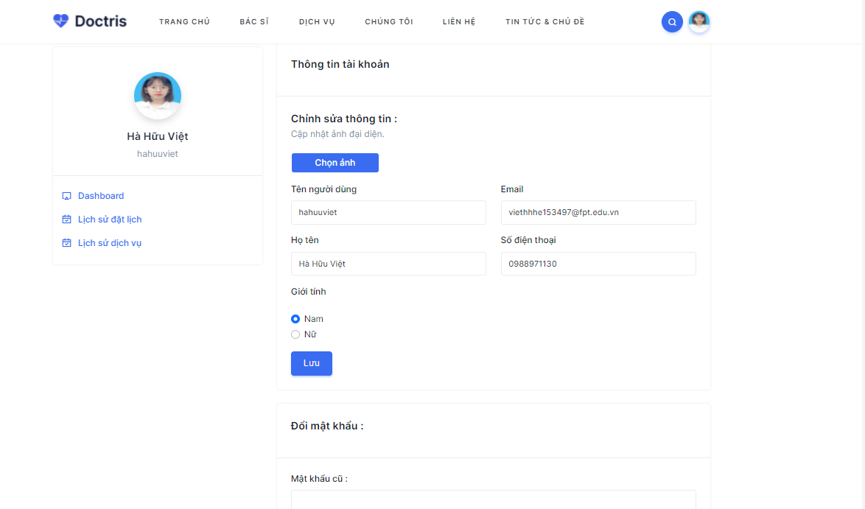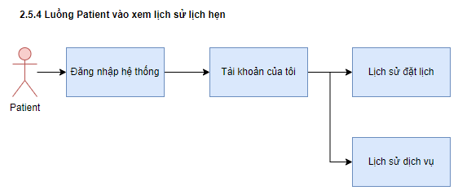

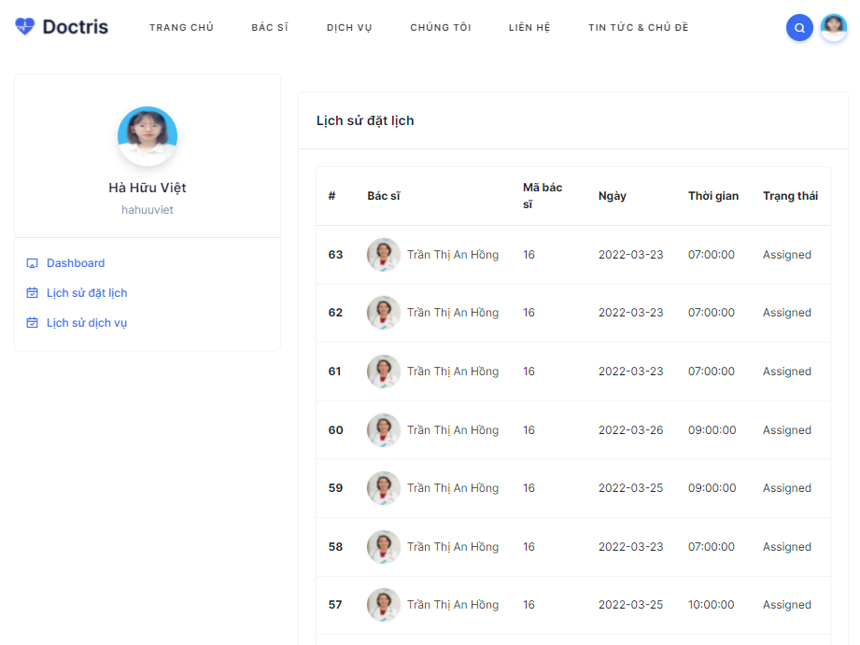

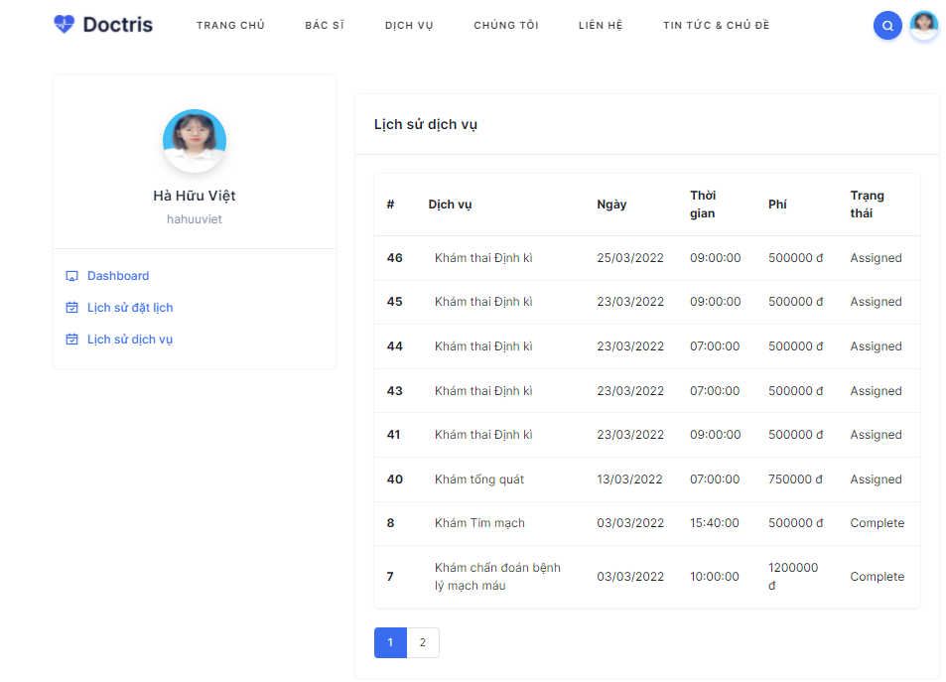

**2.6. Guest**

